Task 3: In a Springboot project implement Constructor injection with @Autowired. Create an interface PaymentService and
implement in class PaymentServiceImpl. Trigger the dependency using a constructor. Expose a REST API to test it.
Step 1: Create Spring Boot Project in Eclipse
Go to:
File → New → Spring Starter Project
- Name: paymentapp
- Type: Maven
- Packaging: Jar
- Java: 17 (or your installed version)
- Group: com.example
- Artifact: paymentapp
Click Next
Add Dependency:
- Spring Web
Click Finish
Step 2: Create Packages Properly
src/main/java
→ New → Package
com.example.paymentapp.controller –
└──PaymentController.java (class)
com.example.paymentapp.service –
├── PaymentService.java (interface)
└── PaymentServiceImpl.java (class)
Step 3: Create PaymentService Interface
service/PaymentService.java
package com.example.demo.service;
public interface PaymentService {
String processPayment(double amount);
}
Step 4: Implement PaymentService
service/PaymentServiceImpl.java
package com.example.demo.service;
import org.springframework.stereotype.Service;
@Service
public class PaymentServiceImpl implements PaymentService {
@Override
public String processPayment(double amount) {
return "Payment of Rs." + amount + " processed successfully!";
}
}
Step 5: Create Controller (Constructor Injection)
controller/PaymentController.java
package com.example.demo.controller;
import org.springframework.beans.factory.annotation.Autowired;
import org.springframework.web.bind.annotation.*;
import com.example.demo.service.PaymentService;
@RestController
@RequestMapping("/payment")
public class PaymentController {
private final PaymentService paymentService
@Autowired
public PaymentController(PaymentService paymentService) {
this.paymentService = paymentService;
}
@GetMapping("/pay")
public String makePayment(@RequestParam double amount) {
return paymentService.processPayment(amount);
}
}
Step 6: Main Class
PaymentappApplication.java
package com.example.demo;
import org.springframework.boot.SpringApplication;
import org.springframework.boot.autoconfigure.SpringBootApplication;
@SpringBootApplication
public class PaymentapppApplication {
public static void main(String[] args) {
SpringApplication.run(PaymentapppApplication.class, args);
}
}

Step 7: Run the Application
Right click → Run As → Spring Boot App
Tomcat started on port 8080
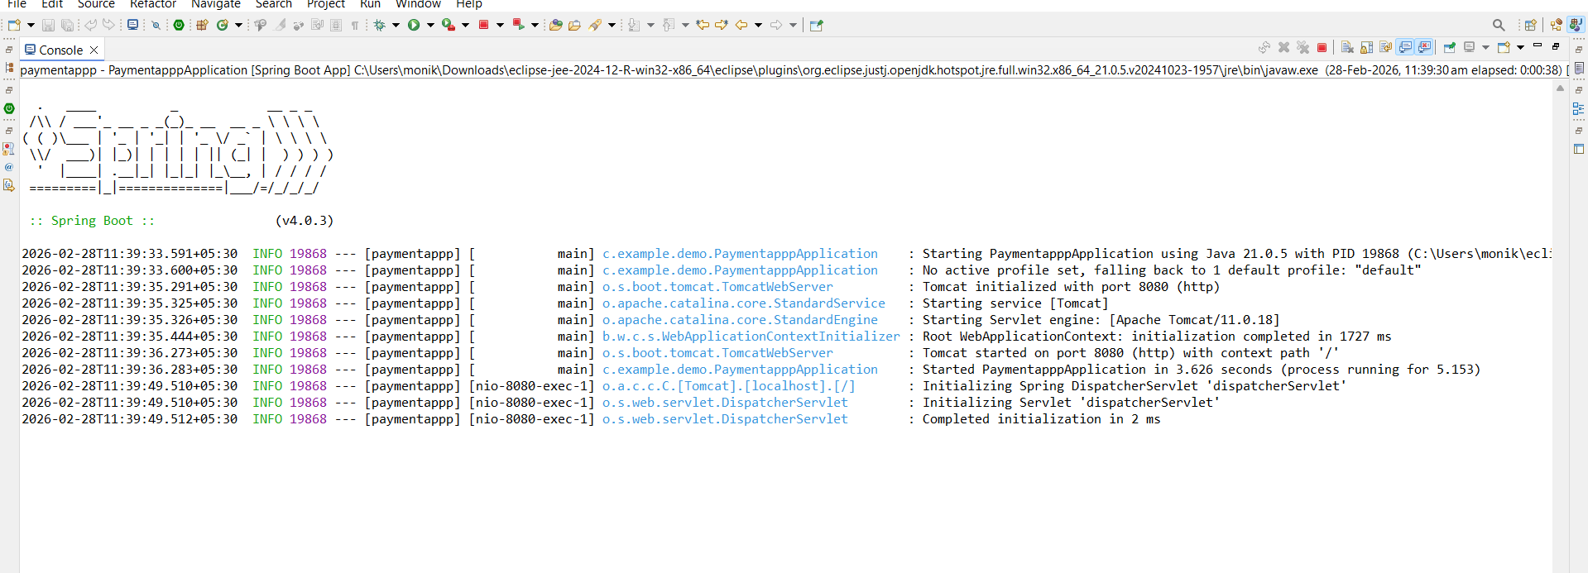

Step 8: Test REST API
http://localhost:8080/payment/pay?amount=5000
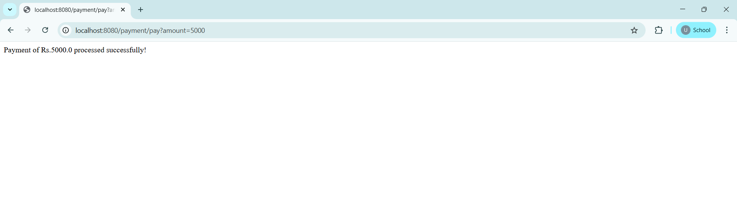

Project Structure Image:
